## Crete user in pythonanywhere

## create a virtual environment using the bach console in the page

* mkvirtualenv oth_venv --python=python3.8

## copy the repository in the desired path

* git clone “repositori_address”

## Checkout to master branch if we are in main

* git checkout master

## install the libraries in the virtual environment using the requirements.txt

* pip install -r requirements.txt

## Make migrations and migrate

## install whitenoise 5.2.0(Optional)

* pip install whitenoise

## In web we must create a new web and follow the steps using manual configuration instead of Django option.

# In web tab look for Code section and WSGI configuration file:

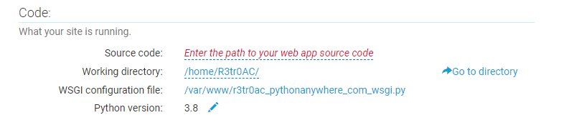

Click on it to edit it and paste in the file the following code:

  
os.environ value should be the path to settings after the path set in path variable(‘/home/R3tr0AC/Oth’)

Add the address to allowed host

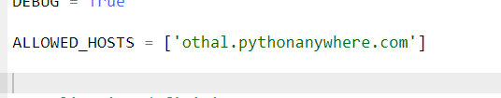

## Set virtual environment path

## Set the static files like this

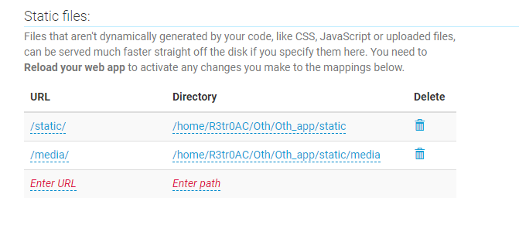

## Fixed the settings.py to recognize the static files:



## Collect the static files

* python manage.py collectstatic

Edited settings.py addresses like this:

